**About ‘UniPhysics’**

I think that the emergence and development of modern physics was a giant leap in the history of mankind. This is because the main theories of modern physics reshaped our perception of the universe and caused an incredible scientific revolution. It is based on the two major breakthroughs of the twentieth century: relativity and quantum theory. Aim of the UniPhysics website is to reconsider the origin of quantum theory for discussion. It is devoted to solve the unsolved problems by classical physics. It believes on one physics and does not believes on bifurcation of physics such as classical and quantum. In universe, one thing cannot have two tempers simultaneously.

**Photoelectric effect:**

I think Einstein’s explanation of photoelectric effect were particularly responsible to develop the theory of quantum mechanics. While explaining the photoelectric effect he proposed that light consists of tiny packets of energy known as photons or light quanta. Each packet carries energy *hv* that is proportional to the frequency *v* of the corresponding electromagnetic wave. Thus he proposed the duel nature of light - wave as well as particle.

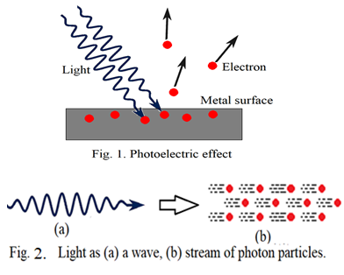

Obviously, once if we accept wave can behave as a particle then a particle should also behave as a wave. That point was raised by de Broglie and proposed the duel nature of matter which reshaped our perception about the universe. Actually wave nature and particle nature are very different from each other. Why people have accepted the duel nature of light is beyond my imagination. I suppose explanation of photoelectric effect using light as electromagnetic wave is possible. In classical physics one thing which we have left is the asymmetric electric field and asymmetric electric force. The asymmetric electric force applied by the electric field in the light wave is responsible to produce the photoelectric effect. It is explained on ‘Photoelectric effect’ page of this website. The asymmetric electric force is responsible to produce an apparent force which is proportional to the frequency of the light wave because of which the kinetic energy of the photoelectrons is found to be proportional to the frequency. The properties of the apparent force are similar to the magnetic force suggesting that the magnetic force produced due to an electromagnetic wave increases with increase in frequency of the wave. It can be experimentally proved. This dependence cannot be supported by the formal classical electrodynamics. Further this discussion suggests that there should be a phase difference of 90 degree between electric field wave and magnetic field wave which is also not supported by the usual classical electrodynamics.

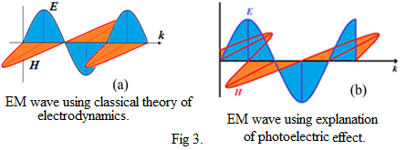

**Total length of single light wave emitted by an atom:**

In lower physics divisions, generally we do Newton’s ring experiment to calculate the wavelength of sodium light. But we ignore on the side that how many rings are to be formed. What is the meaning of the formation of number of rings? Actually if ‘n’ number of rings are formed indicates that ‘n’ number of wavelengths contains in a single light wave emitted by sodium atom. In newton’s ring experiment, suppose we count 200 rings indicates that the total length of single light wave emitted by sodium atom is at least 200 times the wavelength which comes approximately 117860nm. This is very long wave. How it can act as a single photon and how it can be absorbed by a single electron is beyond our imagination. Further, transition of electron, in sodium atom, from higher energy level to lower energy level produces a wave containing 200 wavelengths then the corresponding electron should be oscillated 200 times with the frequency of the wave while producing it. It means we don’t know yet the complete emission mechanism of EM wave of atoms. We have used air-wedge method, as it is better than to Newton’s ring experiment, to count the fringes which is discussed in ‘total length of single light wave emitted by atom’ page.

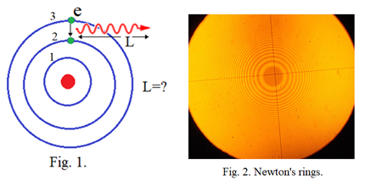

**What is magnetic field?**

Explanation of photoelectric effect says that the electric field in EM wave is asymmetric at major times and produces asymmetric electric force which is responsible to produce an apparent force. The apparent force is proportional to the frequency of the EM wave and can be the true nature of magnetic force. Therefore, the magnetic force produced by an EM wave should increase with increase in frequency of the wave which can be verified experimentally as suggested in ‘What is magnetic field?’ page. It gives answer to why magnetic monopoles are absent in the universe.it will change completely the base of electrodynamics.

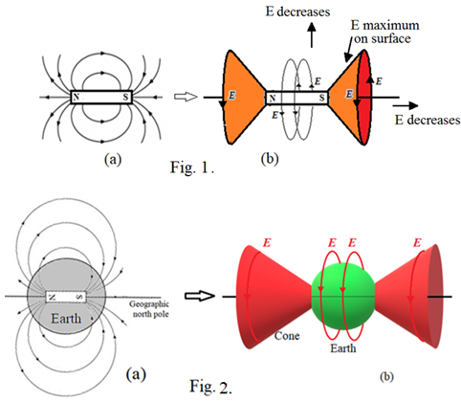

**Atomic structure:**

We have seen by Newton’s ring experiment or air-wedge method experiment that, while transition of an electron from higher energy level to lower energy level in sodium atom, produces an electromagnetic wave containing more than 500 wavelengths indicates that the corresponding electron should be oscillated more than 500 times while producing the wave. It implies that the electrons in the atom may not be revolving around its nucleus. How electrons can maintain their safe distance from the nucleus in atoms using their spin motions without revolving in orbits or without acting as waves is explained in ‘Atomic structure’ page. This atomic model supports to the formation of molecules, compounds and solid materials by atoms.

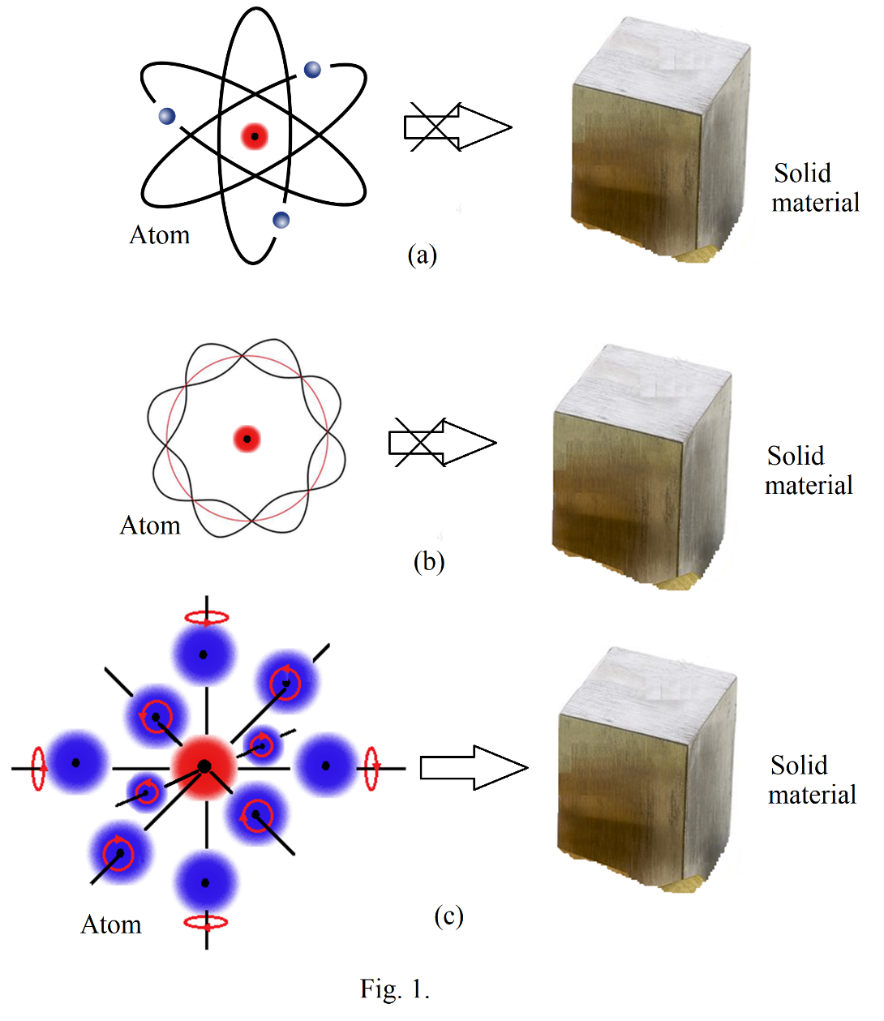

**Reader’s comments:**

Reader’s comments and feedback are welcomed and appreciated. I wanted to thank those of you who have visited to this website. I hope that you are finding some helpful information that may be changing our perception of the universe. It will bring us to the ground. I request all of you to be a part of building the **‘UniPhysics’**. Your valuable comments and suggestions will give right direction to this movement. I request readers to email their comments and suggestions on [ghjadhav@](mailto:ghjadhav@rediffmail.com)uniphysics.org.in that will be placed on ‘Reader’s Comments’ page.